PL/SQL Programming

SuperSet ID:6412063

Exercise 7: Packages

Scenario 1:

Package Specification:

CREATE OR REPLACE PACKAGE CustomerManagement IS

PROCEDURE AddCustomer(p_id NUMBER, p_name VARCHAR2, p_dob DATE, p_balance NUMBER);

PROCEDURE UpdateCustomer(p_id NUMBER, p_name VARCHAR2);

FUNCTION GetBalance(p_id NUMBER) RETURN NUMBER;

END CustomerManagement;

/

Package Body:

CREATE OR REPLACE PACKAGE BODY CustomerManagement IS

PROCEDURE AddCustomer(p_id NUMBER, p_name VARCHAR2, p_dob DATE, p_balance NUMBER) IS

BEGIN

INSERT INTO Customers (CustomerID, Name, DOB, Balance, LastModified)

VALUES (p_id, p_name, p_dob, p_balance, SYSDATE);

DBMS_OUTPUT.PUT_LINE('Customer Added: ' || p_name);

EXCEPTION

WHEN DUP_VAL_ON_INDEX THEN

DBMS_OUTPUT.PUT_LINE('Customer ID already exists.');

END;

PROCEDURE UpdateCustomer(p_id NUMBER, p_name VARCHAR2) IS

BEGIN

UPDATE Customers

SET Name = p_name

WHERE CustomerID = p_id;

DBMS_OUTPUT.PUT_LINE('Customer Updated: ' || p_id);

END;

FUNCTION GetBalance(p_id NUMBER) RETURN NUMBER IS

v_balance NUMBER;

BEGIN

SELECT Balance INTO v_balance FROM Customers WHERE CustomerID = p_id;

RETURN v_balance;

EXCEPTION

WHEN NO_DATA_FOUND THEN

RETURN -1;

END;

END CustomerManagement;

/

Test Calls:

SET SERVEROUTPUT ON;

BEGIN

CustomerManagement.AddCustomer(201, 'Ravi Kumar', TO_DATE('1990-06-15', 'YYYY-MM-DD'), 8000);

CustomerManagement.UpdateCustomer(201, 'Ravi K');

DBMS_OUTPUT.PUT_LINE('Balance: ' || CustomerManagement.GetBalance(201));

END;

/

Output:

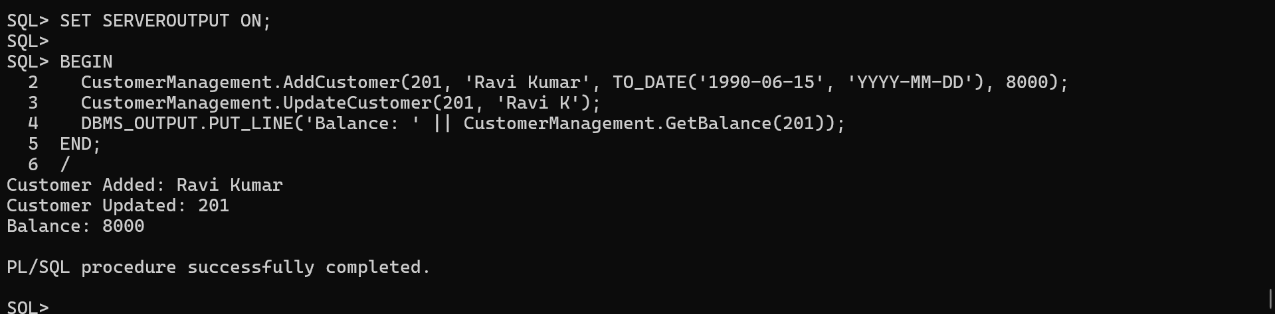

Scenario 2:

Package Specification:

CREATE OR REPLACE PACKAGE EmployeeManagement IS

PROCEDURE HireEmployee(p_id NUMBER, p_name VARCHAR2, p_pos VARCHAR2, p_salary NUMBER, p_dept VARCHAR2, p_hire DATE);

PROCEDURE UpdateEmployee(p_id NUMBER, p_salary NUMBER);

FUNCTION GetAnnualSalary(p_id NUMBER) RETURN NUMBER;

END EmployeeManagement;

/

Package Body:

CREATE OR REPLACE PACKAGE BODY EmployeeManagement IS

PROCEDURE HireEmployee(p_id NUMBER, p_name VARCHAR2, p_pos VARCHAR2, p_salary NUMBER, p_dept VARCHAR2, p_hire DATE) IS

BEGIN

INSERT INTO Employees VALUES (p_id, p_name, p_pos, p_salary, p_dept, p_hire);

DBMS_OUTPUT.PUT_LINE('Employee Hired: ' || p_name);

END;

PROCEDURE UpdateEmployee(p_id NUMBER, p_salary NUMBER) IS

BEGIN

UPDATE Employees SET Salary = p_salary WHERE EmployeeID = p_id;

DBMS_OUTPUT.PUT_LINE('Employee Updated: ' || p_id);

END;

FUNCTION GetAnnualSalary(p_id NUMBER) RETURN NUMBER IS

v_salary NUMBER;

BEGIN

SELECT Salary * 12 INTO v_salary FROM Employees WHERE EmployeeID = p_id;

RETURN v_salary;

END;

END EmployeeManagement;

/

Test calls:

BEGIN

EmployeeManagement.HireEmployee(301, 'Sneha Rao', 'Analyst', 40000, 'Finance', TO_DATE('2023-01-01', 'YYYY-MM-DD'));

EmployeeManagement.UpdateEmployee(301, 45000);

DBMS_OUTPUT.PUT_LINE('Annual Salary: ' || EmployeeManagement.GetAnnualSalary(301));

END;

/

Output:

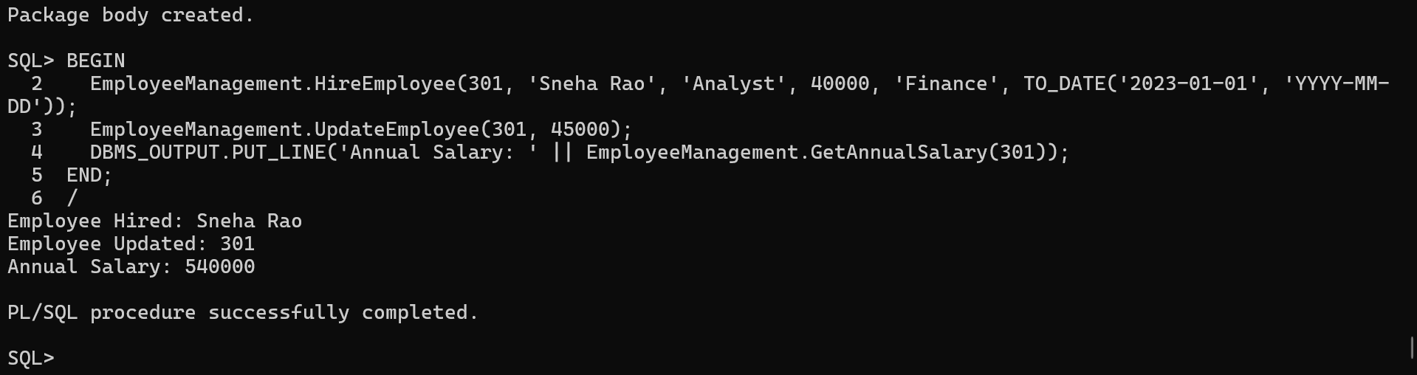

Scenario 3:

Package Specification:

CREATE OR REPLACE PACKAGE AccountOperations IS

PROCEDURE OpenAccount(p_acc_id NUMBER, p_cust_id NUMBER, p_type VARCHAR2, p_balance NUMBER);

PROCEDURE CloseAccount(p_acc_id NUMBER);

FUNCTION GetTotalBalance(p_cust_id NUMBER) RETURN NUMBER;

END AccountOperations;

/

Package Body:

CREATE OR REPLACE PACKAGE BODY AccountOperations IS

PROCEDURE OpenAccount(p_acc_id NUMBER, p_cust_id NUMBER, p_type VARCHAR2, p_balance NUMBER) IS

BEGIN

INSERT INTO Accounts (AccountID, CustomerID, AccountType, Balance, LastModified)

VALUES (p_acc_id, p_cust_id, p_type, p_balance, SYSDATE);

DBMS_OUTPUT.PUT_LINE('Account Opened: ' || p_acc_id);

END;

PROCEDURE CloseAccount(p_acc_id NUMBER) IS

BEGIN

DELETE FROM Accounts WHERE AccountID = p_acc_id;

DBMS_OUTPUT.PUT_LINE('Account Closed: ' || p_acc_id);

END;

FUNCTION GetTotalBalance(p_cust_id NUMBER) RETURN NUMBER IS

v_total NUMBER;

BEGIN

SELECT SUM(Balance) INTO v_total FROM Accounts WHERE CustomerID = p_cust_id;

RETURN NVL(v_total, 0);

END;

END AccountOperations;

/

Test calls:

BEGIN

AccountOperations.OpenAccount(401, 201, 'Savings', 5000);

DBMS_OUTPUT.PUT_LINE('Total Balance: ' || AccountOperations.GetTotalBalance(201));

AccountOperations.CloseAccount(401);

END;

/

Output:

